Strings

* Syntax: “string”

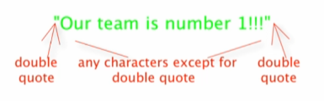

string-append

* Put strings together
* (string-append “string1” “string 2” …)

You cannot add a number and a string

 -> 

string-length

* Returns the number of characters in a string
* (string-length “string”)

substring

* Takes out a part of a string
* Like slice
* (substring “string” [index1] [index2])



* From index1 to before index2



* 0 based indexing
  + Start 0 in counting indexes